**Sports Action Plan (SAP)**

*Prepared For*

**Professor Nand Singh**

**Master Project Plan**

**OREM 7356 - Fall 2022**

*Prepared By*



**Hareish Raghupathy**

Date: 11/25/2022

**___________________________________________________________________**

(To be Reviewed By or On Behalf Of Professor Nand Singh)

**Table of Contents**

1. ***Management Summary …………………………………………………………………..…...3***
   1. Project Description ……………………………………………………………………..3
   2. Objectives ……………………………………………………………………………….3
   3. Resource Requirements ……………………………………………………………….5
   4. Constraints ………………………………………………………………………………6
   5. Problem Areas and Solution …………………………………………………………..6
   6. A Master Schedule with Major Events and Milestones ……………………………..7
2. ***Management and Organization ……………………………………………………………...8***
   1. Project Management and Organization ………………………………………………8
   2. Manpower ……………………………………………………………………………….9
   3. Training and Development …………………………………………………………….9
3. ***Technical Solution …………………………………………………………………………...10***
   1. Scope of Work …………………………………………………………………………10
   2. Work Breakdown ………………………………………………………………………13
   3. Responsibility Assignment …………………………………………………………...14
   4. Project Schedules ……………………………………………………………………..16
   5. Budget and Financial Support ……………………………………………………….18
   6. Testing of Deliverables ………………………………………………………………..19
   7. Change Control Plan ………………………………………………………………….19
   8. Work Review Plan …………………………………………………………………….19
   9. Documentation ………………………………………………………………………...20
   10. Implementation ………………………………………………………………………..21
   11. Economic Justification ………………………………………………………………..22
   12. Areas of Uncertainty and Risk ……………………………………………………….22
   13. Implementation of Internal Controls and Compliance ……………………………..24
4. ***Communication Plan ………………………………………………………………………...24***
   1. Project Audience ………………………………………………………………………24
   2. Information Needs …………………………………………………………………….25
   3. Communications Calendar …………………………………………………………...27
   4. Format/Delivery ………………………………………………………………………..27
   5. Approvals ………………………………………………………………………………29
   6. Escalation ………………………………………………………………………………29
   7. Contact Information …………………………………………………………………...30

*Total No of Pages :* ***30***

1. **Management Summary**
   1. **Project Description**

Our sports institute’s performance and results have gone down drastically because of the Covid crisis over the past two years. This has led to the complete shutdown of the training programs and functioning of the institute. Because of this there is a lot of heavy criticism and negative feedback coming from the personnel who have already been enrolled in the program. This further has deteriorated the company’s value and reputation since the rate of admission into the program is the lowest since its inception in 2001.

The main objective of this SAP is to initiate and deploy a new set of activities with the help of IT, data and sports research personnel along with field engineers and sporting directors to enhance the training and output of the company. This would lead to the continuation of sports in virtual and physical mode by means of hybrid programs and plans. The use of technology to conduct sports in virtual mode via voice and video with the help of a specifically designed activity tracker via an application would be a revolution in this sector.

This would not only help the company to recover from the loss of traction and fame among the customers but also will set an example for the other institutes in the country to adapt this new method to have an optimal performance irrespective of the outbreak and its aftermath. The design of SAP will revolve around providing the appropriate activities, workouts and competitions to the customers in a customized manner with respect to the nature of their sport. SAP will focus on delivering its objectives on time, within the projected cost while ensuring all the customer and company requirements are met.

This Sports Action Plan will be sponsored by the National Head Director Of Sports and Management. This will require resources across various sectors including IT, data analysis, research and predictive analysis, systems engineering, design architecture, field engineering, sports management and instruction, ground facility department, sports supervision, finance, operation and support and others. This is a project of precedence in the community of sports and takes the number one priority in our company.

* 1. **Objectives**

The following fundamental objectives must be accomplished:

1. **Cost** - The SAP must have its budget under the allocated amount which is 2.2 Million Dollars.
2. **Schedule** - The SAP must be initiated in the calendar year 2023 in the month of August.
3. **Performance** - The projected action plan must satisfy all the customer and company requirements.

The **Critical Success Factors** to be accomplished are:

1. Increase the flexibility of the entire training module with a cluster of Hybrid, Physical and Virtual events.
2. Successful deployment of a system infrastructure team to aid activity monitoring and data collection of every athlete in the training program of the company.
3. Accessibility of the tracking application to athletes and trainers at all times with proper authorization and security of data.
4. Allocation of trained supervisors and instructors to successfully implement SAP, using all of its functional advantages.
5. Implementation of a health monitoring system along with diet suggestion facility to ensure body fitness of the users.
6. Deployment of structured competitions online to make physical sports possible by virtual mode.
7. Enable distance training possible with the instructors while not being present on the ground.
8. Implementation of a recognition and rewarding system to encourage and motivate the achievers while indirectly helping the company’s sporting reputation grow.

The following **Gate reviews or Milestone reviews** must be completed before proceeding to the next stage:

1. Opportunity Evaluation / Feasibility Review
2. Preliminary Design Review
3. Critical Design Review
4. Program Deployment Readiness Review
5. Program Performance Review
6. Project Closure

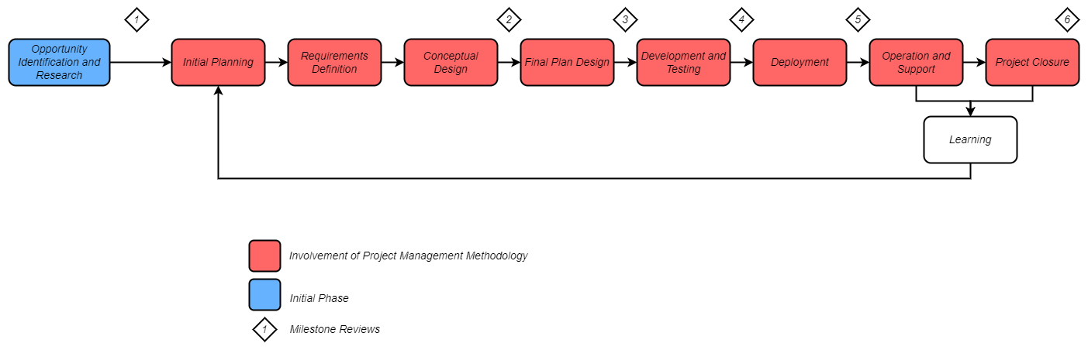

*Fig 1 : Project Lifecycle*

* 1. **Resource Requirements**

The following are the resources required to complete the SAP successfully:

1. **Money** - Budget will be required in the SAP to build the tracking application, payment for its service, purchase new electronic equipment to set up the system infrastructure, to training operators, to maintain data, to get sporting and ground equipment and other low cost requirements. On top of this there will be direct and indirect costs associated with the project along with labor costs, traveling costs and reward or recognition costs.
2. **Manpower** - Experts from various functional groups are required to plan, design, develop, deploy and maintain the project throughout the course of its lifetime. Project management, program management, executive direction, data collection and management, IT, R&D, finance, HR, procurement, acquisition, training and other related departments.
3. **Material** - Some of the important materials include proper racks to store the sporting goods and electronic equipment, transport materials required at the fields, shipping materials, ground requirements like marking materials and consumables used for all the devices and equipment etc.
4. **Facilities** - Firstly, the sports headquarters will consist of a separate building in which all the necessary facilities are provided. Some of the key components are comfortable staff and executive work space with separate desks and conference rooms, the space to set up the equipment, inventory to store things, connections and electricity to set up the devices etc.
5. **Equipment** - Procurement of a new web based application service to establish a regular activity link with the individuals, new desktops or laptops in the HQ for every team to track and monitor every individual athlete’s activities, softwares tools to analyze and predict the development of athletes, data analysis softwares to collect data and use it for analyzing sports trends and most favorable path etc
6. **IT** - IT services are required to host the web based tracking application, to provide a seamless online interaction between the athletes, trainers and team managers, to collect the information from data analysis and use it to do a predictive analysis through various modeling and testing, provide maximum functionality with the equipments at the headquarters
   1. **Constraints**

The project plan is supposed to follow the constraints listed below:

1. The cost and schedule must be met without any extension to it.
2. Baseline of the project must be verified and validated by the project sponsor at every stage.
3. All the requirements must be met before formulating the final plan.
4. All allocated resources are to be highly allocated in the key stages like the design review to eliminate any potential failures as early as possible, reducing changes or rework to the project.
5. Training staff are required to validate the performance of the individual operators they have trained and submit the documented report to the project manager.
6. All the public and corporate laws are to be adhered to while deciding on any action.
7. This project shall not affect the functioning of the current training program for more than 1 week.
8. Operating/ support staff are to be present in the respective team’s peripheral at any given time after the deployment of the system.
   1. **Problem Areas and Solution:**
9. **Usage of New Technologies** - Various techniques and methods used in the SAP include new desktop environment, Analyzing IT and data center, Monitoring and alerting athletes through web based applications and Virtual events etc. The best way to incorporate these is to provide training to the relevant staff who control the athlete’s training program and evaluate their capabilities and performance to bring about a suitable structure for both the training institute and the customers.
10. **Complexity** - This system is very complex in contrast to the traditional system where there has been only physical mode of training. The new SAP combines physical, virtual and hybrid events along with competitions and recognition reward programs. Proper organizational structure, project management, control, staffing and problem solving would alleviate the difficulty in time with respect to installation, deployment and operation at optimal level.
11. **Resource Availability** -Sporting institutes usually have limited human resources. This is okay for a traditional structure in sports for physical mode but this SAP requires extra manpower to organize, manage and evaluate all the activities while monitoring every sport and athlete separately via the application services. Provided SAP has been granted the top priority in our company, we should recruit experts for all the new technologies/ methods implemented so that they can help the different staff team carry themselves in future while managing them.
12. **Customer Expectation** - Virtual mode in SAP and sports does not go along well. This is highly anticipated to be disliked by the customers training traditionally. To give convincing and confident evidence that this system of training module is going to be a game changer in sports, a demo model showing the statistics of a user training normally and a user training under SAP should be designed to compare and highlight all the benefits of our program. Later the actual athlete’s results are to be documented to keep track of the program’s worth and success rate.

* 1. **Master Schedule Showing Overall Events:**

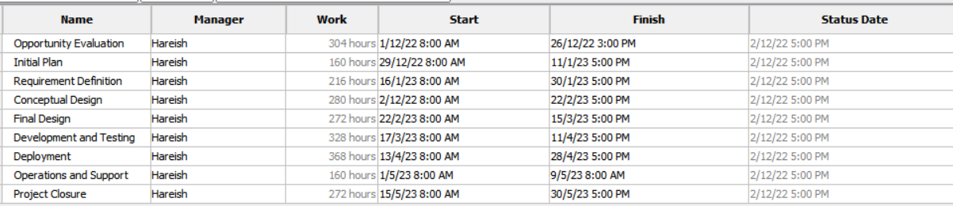

**[Note:** A detailed project plan will be shown late in the MPP in section 3.4**]**

**Gate Review Timeline:**

1.Feasibility Analysis [After Opportunity Evaluation]

2.Preliminary Design Review [After Conceptual Design]

3.Critical Design Review [After Final Design]

4.Program Deployment Readiness Review [After Development and Testing]

5.Program Performance Review [After Operations and Support]

6.Project Closure [At the end of the Master Project Plan]

1. **Management and Organization**
   1. **Project Management and Organization Type**

The project will have a matrix organizational structure which is modified as per the requirements with respect to the inputs from the sporting director to ensure smooth and suitable operation throughout its life cycle.

The project manager assumes control with the help of function manager and other team leads from the initial phase till the closure of the project plan.

The Sponsor of the project here would be the Sporting Director. The project manager will work with the IT and Technical team to implement new technologies and support in its operational use; with field engineers and sports managers to implement the training modules for athletes; HR to allocate appropriate work and control measures; Systems team to design the project plan; Business team and manager to analyze results and risks; Training team to ensure availability of skilled resources; and also maintain a good relationship with the customer while ensuring the requirements are met at every stage and validated. There are various other roles the project manager and various departments and leads should do in order to successfully implement the SAP system. Some of the key tasks will be discussed later in the plan.

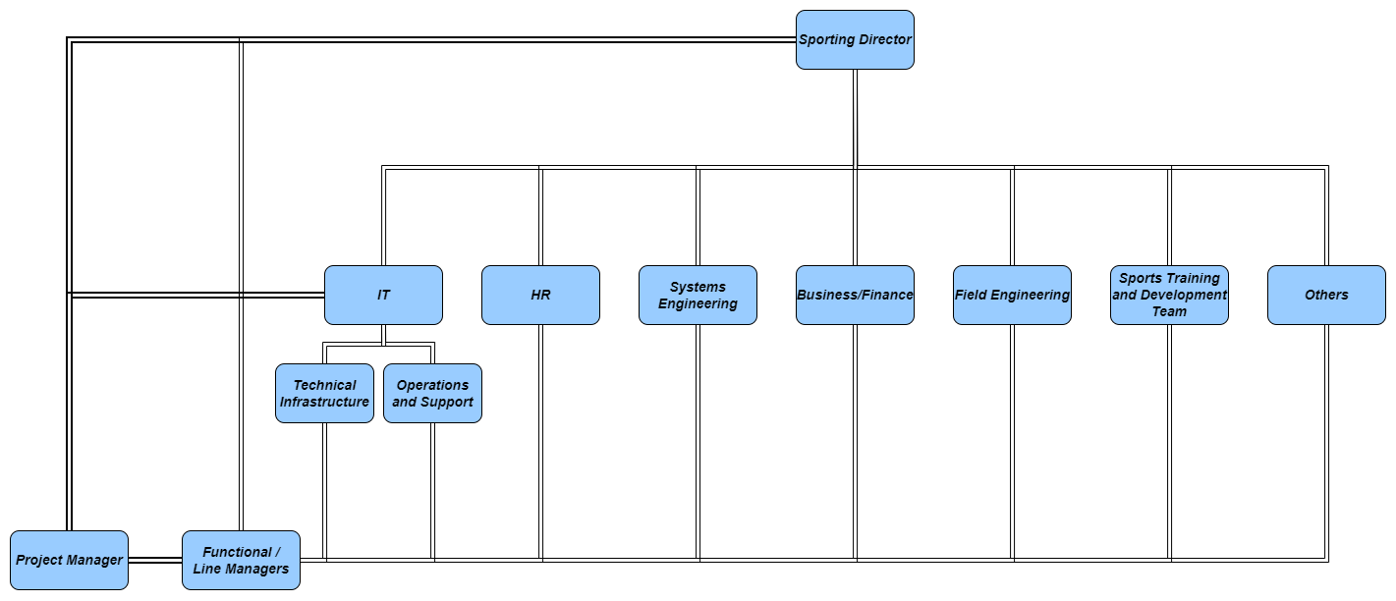

*Fig 2: Organizational Structure*

* 1. **Manpower**

Skillsets required by the resources will be identified earlier on after formulating a feasible solution for the statement. Every manager or leader’s area of expertise and experience will play an important role in their allocation to specific tasks and responsibilities in WBS.

There are situations where an entirely new team is to be allocated for certain tasks like the Field Engineering team implemented here which is specific to SAP, this is done when there is a requirement of an expert to cover works related to that work package. These professionals will either be recruited by the HR or be trained by recruited experts based on inputs from the functional manager. On the other hand, sometimes individuals assume dual or multiple roles to perform in tasks related to their team. For instance, SAP did not require a separate writing team as the SE team members and Core team have taken up that documenting work along with the weekly reports.

Functional manager, SE Lead, Technical lead, Operations Lead and HR will be included while making the decisions for this.

All the Key Members/ Teams needed for the operation of this project are mentioned in section **3.3**.

* 1. **Training & Development**

The SAP is quite an intensive task with the current levels of skill sets and methods followed by the team. Therefore, more staff are to be trained to ensure the maximum utilization of the technologies and newer systems developed to maximize the Institute’s growth, output and efficiency while setting a new benchmark in the sports community.This can be achieved by allocating trainers to training the current staffs to operate the system optimally, allocating experts staffs if necessary to perform key monitoring tasks and maintaining the data set of every individual athlete in his physical, virtual and hybrid platforms. The mental and health training modules for the athlete must be verified by a physiotherapist and psychologist.

All the key objectives of each team and departments must be elaborated before the commencement of the training program. The SE lead, IT lead, Design lead, Technical lead, Field and Ground work leads, and the Sports management leads must understand the whole process and concept of operation of the full system before projecting the work flows and systems expectation onto their teams.

1. **Technical Solution**
   1. **Scope of System**

**Program Infrastructure and Working**

The Sports Action Plan’s Infrastructure will consist of a new sports headquarters which will act as the main control center and data center for the operation of the whole system and other subsystems under the influence of the Director of sports. This is typically the heart of the whole SAP.

This diagram shows the contrast between the operational flow of previously Implemented system vs the newly proposed SAP:

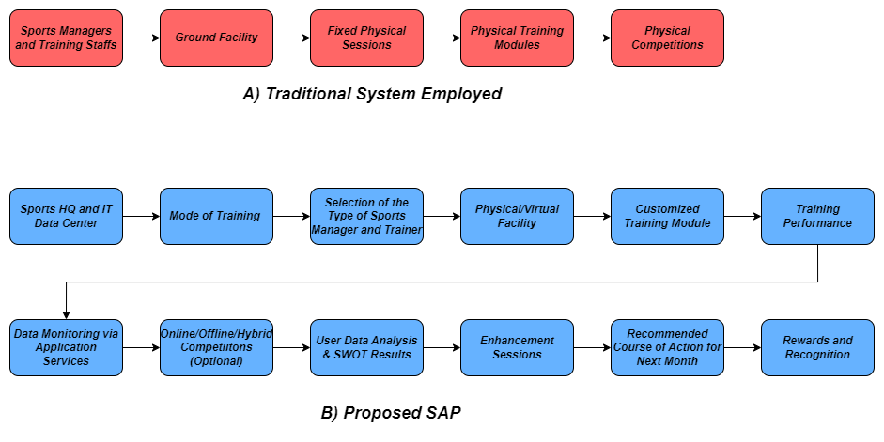

*Fig 3: SAP Functional Diagram*

**Let us look at the above diagram in detail,**

1. **Traditional System:**

This is a typical example of how a normally functioning sports training infrastructure works. The users of the system or the athletes are present physically in the ground, sports team managers and training professionals train them in the available facility space, there is only a fixed static training model for the athletes and finally they are sent to the tournaments to perform at a much higher stage.

Though this method is the current standard, this does not exploit the full potential of the athletes and contribute to a wastage of time. Not to mention, this method has proved to be totally ineffective and void across the nation during the covid crisis.

1. **Sports Action Plan (SAP):**

* The Control Mechanism - This consists of the sports headquarters, IT data center, selection of the training mode and type of training personnel. The HQ controls the operation, the data center collects data and optimizes individual models for training and the personnel implement it.

The individuals are required to select a training session to commence training.The training staff and models are recommended by the application but if the athlete wants a trainer or a model that specifically suits his need, the user can choose that personnel. If an individual decides to deviate from it and take a customized course of action which they can do using the selection of mode and training personnel. This provides him with extreme flexibility as the training can be done physically, virtually and in a hybrid mode too.

* Smart Services - The SAP requires the building or outsourcing of a software application capable of tracking the user’s data. This application is supposed to be installed in every athlete’s trackers or mobile phones. This helps in analyzing the data to provide an optimal path to training based on the user’s body and health conditions The monitoring of every specific athlete is done in the datacenter with the help of training professionals by means of predictive performance analysis and customizing training models on a regular basis using the data collected from the user’s activity.
* Training Optimization - The training professionals are given a customized set of training modules with respect to every team and every individual which would aid them in providing better results with the athletes. Once optimal data is accumulated from the application at the end of the month, it can provide a SWOT analysis of the individual with respect to the user's sport. This could provide further information to the trainers whether the user needs physical, mental, physiological, or psychological help to enhance their performance.The trainer can always access and monitor the user’s body condition, limits and other data that has increased or decreased his performance.
* Health - The ability of the data center and training professionals to evaluate the health metrics with the data is highly useful as they can provide health alerts to the user and the trainer incase of any deviations from normal activity. Apart from tracking health, this mechanism is capable of providing recommended diets to ensure peak body conditions throughout the training period.
* Virtual Training Modules and Competitions - Virtual training can be implemented virtually with the help of IT and communications teams. This module is facilitated by a training professional virtually and it can also be set to use minimal space in the environment if the user has less space. Apart from physical competition in sports, this system also allows engaging the users in a hybrid/virtual competition with the help of communications and IT teams. Most sports contain unique elements which can be performed from afar like freestyle skills apart from the traditional game which often goes unnoticed. This whole virtual forum serves as a good alternative to keep the community engaged even during a lockdown scenario. This is an added bonus in the SAP apart from the revolutionary changes made to the training module.
* Rewarding System - Apart from the above mentioned metrics, the data center also tracks the performance of every individual while calculating all the parameters like work ethic, diet, team performance, consistency etc, it provides the data of the best individuals in each team who would then be awarded the best athlete of the month.

Inorder to make SAP collaborative and efficient it requires supports from the following resources during its operation:

1. HQ and IT Data Center - A fully functional team of data analysts, training model analyst (usually a training professional with specialization), and IT team to effectively enable synchronization and communication throughout the inter-connected application designed for users and trainers.
2. Application - A web based application that is compatible with any activity tracker, mobile or pc. This application should enable the data monitoring, collection and communication with the user.
3. Training Facility - The training facility is the key component of a physical training session which cannot be compromised on. During the virtual session requirement of a smart device becomes mandatory. Field engineers and ground work supervisors must make sure of this.
4. Sports Team Managers and Training Professional - They are the point of contact between the users and the institute organization. It is their responsibility to oversee the training process and keep track of the users with the help of the facilities available. They are key to providing results.
5. IT Operations & Support Staff - They are the ones who enable the overall communication across the organization, the customers and the users. They play a key role during the implementation of any virtual or hybrid activity.
6. User Analysis Team - They are the ones responsible for identifying the negatives and positives of a user in order to improve their performance. Therefore, this team should be well trained in various aspects of sports and health. They are vital in analyzing personal data and providing the best future course of action for the user.
7. Management Team - This team oversees all the different functions of the SAP by setting up a proper organizational structure to ensure the optimal working of every department after the implementation of SAP and training of staff for the usage of newly implemented technology. A proper management is key to providing better results while adapting a system like SAP which could become complicated especially with a lot of data collection, individual analysis and communication with different levels involved in it.
   1. **Work Break Down**

The project is divided into 9 major work packages:

1. **Opportunity Evaluation -** This is the initial phase of the project where the nature of the problem is evaluated upon finding opportunity and errors based on risk assessment, feasibility, business study and solution ideation.
2. **Initial Planning -** This stage involves the definition of the revised feasible business statement. It also states the expectation and goals of the project while establishing cost, schedule and performance metrics including the formulation of initial documentation.
3. **Requirements Definition -** This phase includes the gathering of various requirements for the project including the sponsor, company, customer, owner, user, technical team, developer and other stakeholders.
4. **Conceptual Design -** In this stage, the completion of initial design activities is done which includes the concept and design while providing the necessary facilities for it. Alternative analysis, change management and configuration management is implemented at this stage.
5. **Final Design -** The design package is finalized, reviewed and completed here while validating if all the other detailed requirements are met.
6. **Development and Test -** This stage commences the development of the plans and designs, installation of the necessary components for test and development in the environment.
7. **Deployment -** This involves budget and resource allocation or acquisition for the installation of the developed product along with the infrastructure required for its functionality. The customers and users are integrated to the system at this stage.
8. **Operation and Support -** This involves the trained operating and service personnel allocation to their respective roles to ensure successful operation of the system while providing support for it.
9. **Project Closure -** This is the end of the project that involves the completion of all formal documentation,evaluation of the performance, identifying the lessons learned, providing rewards and reviews, and settling all the charges and costs while ensuring a properly filed closure of the project.
   1. **Responsibility Assignment**

| **Role** | **Responsibility** | **Personnel** |
| --- | --- | --- |
| Business Director | Business Head of the organization |  |
| Business Manager | Business analysis and decision making in opportunity evaluation with respect to IT data and project forecast |  |
| Core Team | Primary responsible for the implementation of the project |  |
| Sporting Director | Head of all sporting activities and systems at play |  |
| Executive Sponsor | Sponsor of the project |  |
| Project Manager | Responsible for the deliverables and cost, schedule, performance parameters |  |
| Functional Manager | Responsible for overall staffing and supervision |  |
| Systems Engineering Lead | Responsible for formulating lifecycle processes |  |
| SE Team | Works in the development of the lifecycle process,change management, configuration management |  |
| Design Team | Responsible for the design and architecture of the plan |  |
| Test and Validation Team | Verification and validation against the requirements or deliverables |  |
| Data Analysis and Research Team | Collection and analysis of data required by various teams, R&D |  |
| Sports Team Managers & Supervisors | Manage and supervise the different sporting teams respectively, provide coaching for the athletes, point of contact or communication to the athletes/customers |  |
| Inplant Training Personnel | Responsible for training the HQ staffs and IT staffs to adhere to the newer methods and technologies |  |
| IT Lead | Head IT personnel responsible for IT developments and decisions |  |
| IT Admin | Administrator who controls information, data and communication in the HQ |  |
| Finance Team | Costing, market trend and economic analysis |  |
| Field Engineering Supervisor | Responsible for training infrastructure and sports equipments |  |
| Groundwork Supervisor | Responsible for the maintenance and |  |
| HR | Staff and employer selection, training and allocation |  |
| Operations and Service Team | Responsible to provide the services required using the facilities provided to them in the HQ |  |
| Customer Focals | Personnel from customer side to provide insights |  |

**[Note:** The names of the Personnel are not stated as there is no actual individual working on this project. However, this is the format in which the Responsibility assignment takes place where the respective individual’s names are included in the actual scenario**]**

* 1. **Project Schedule**

The following representation shows the WBS structure for the work to be done for the initiation of SAP and the scheduled work process for it. The Work starts on 1/12/22 and ends on 30/5/23 which is around 6 months. The total hours of work put in this period is 2400 hours.

The table below shows all the different activities and various tasks to be done in every major stage during the Lifecycle of the project and its program plan.

1. Opportunity Evaluation -

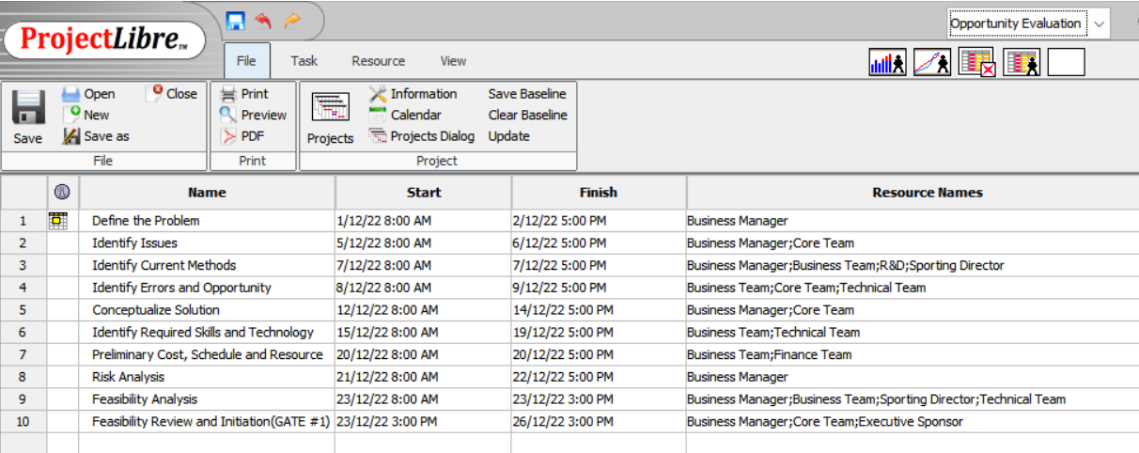

1. Initial Planning -

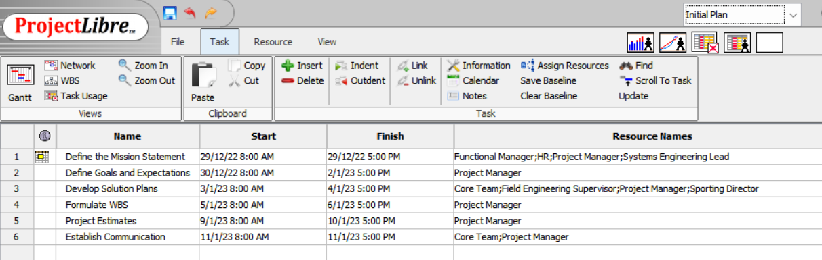

1. Requirements Definition -

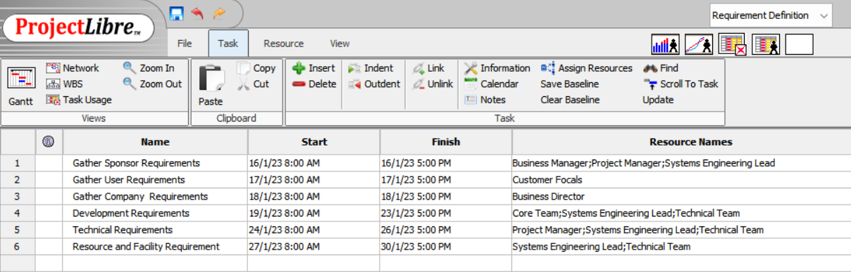

1. Conceptual Design -

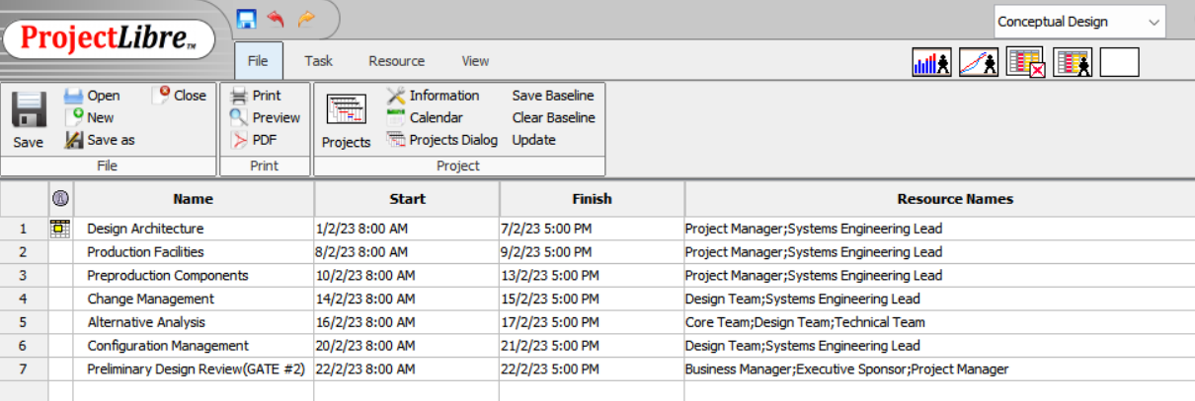

1. Final Design -

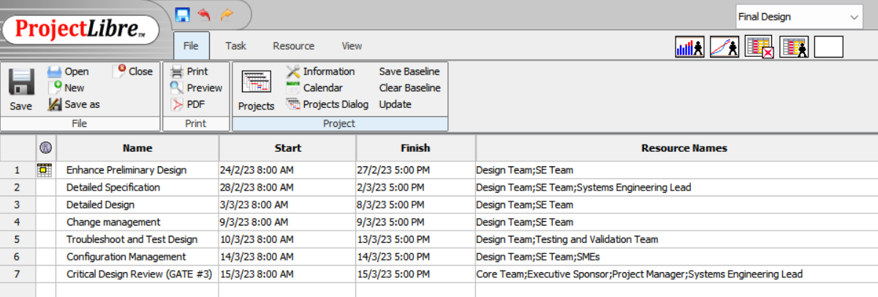

1. Plan Development and Test -

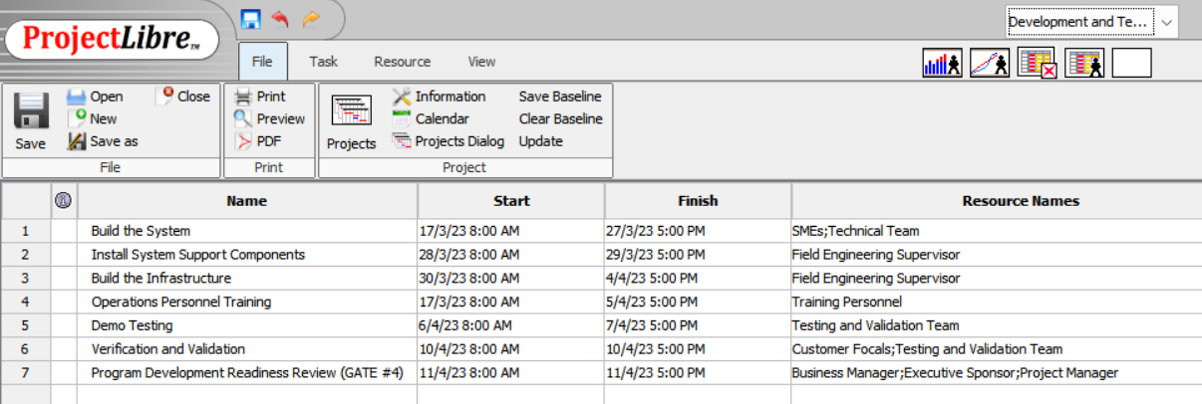

1. Deployment -

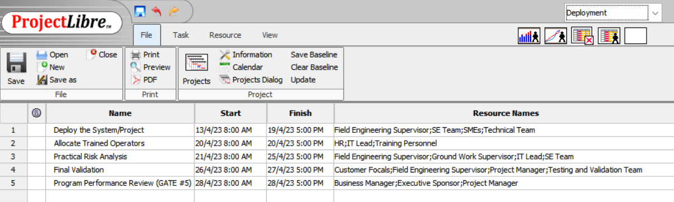

1. Operation and Support -

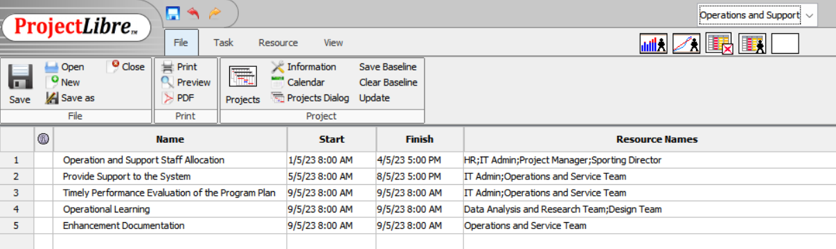

1. Project Closure -

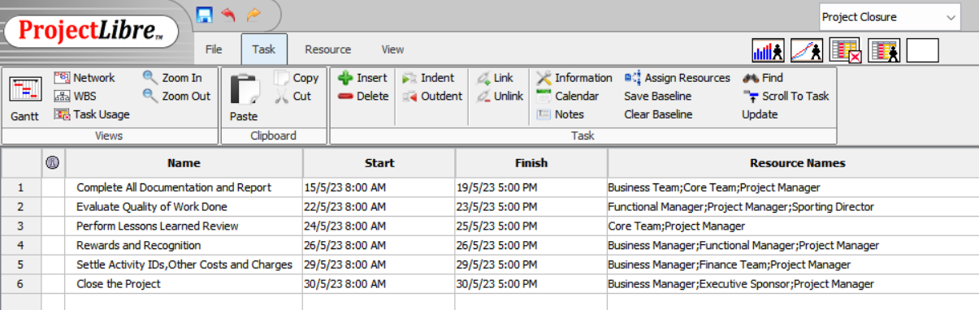

* 1. **Budget and Finance**

The budget and finance for the SAP must be approved by the Sporting Director and Business Manager. The following table depicts the budget requirement for each component of the program plan.

| **Component** | **Budget Type** | **Amount in $** | **When it is Needed** |
| --- | --- | --- | --- |
| Facility | Direct | 100,000 | During all the stages |
| Equipment | Direct | 150,000 | During all the stages |
| Material | Expense | 50,000 | By April 2023 |
| Hardware | Direct | 150,000 | By February 2023 |
| Software | Direct/Service Expense | 250,000 | By February 2023 |
| Fixed Labor (Estimated Average of $50/hour) | Direct | 1,200,000 | During all the stages |
| Management Reserve | Direct | 250,000 | - |

* 1. **Testing of Deliverables**

The test and verification team will have a set of strategies adopted as per the nature of the project to validate the deliverables produced by the system.

This usually consists of:

* Hardware working
* Software performance
* Operation and support functionality
* Risk area analysis
* Failure management
* Vulnerability testing
* Penetration testing
* Requirements testing
* Performance testing
* Reactive and regression testing of the plan

Final approval by the testing team requires a validation for all the above elements during the verification and validation phase so as to ensure all the deliverable requirements are met while having adequate safety and security in the operation of the SAP.

* 1. **Change Control Plan**

The change control is usually performed by the change personnel in the SE team. This change management meeting would be done in the presence of the change management expert, project manager, core team, and the team from which the change request has been put forth by.

After validating the reason for the change, a change record is to be created if it has any effect on the cost, schedule and scope metrics. This record report will be put forth in the meeting and decided upon the inputs from the teams present there. In emergency cases, a change request can be placed and decided upon by email after recording it in the change management worksheet/tool.

After the approvals of the change , it must still be approved by the sponsor to be incorporated into the system. This will then be reflected upon and updated in the configuration management section of the project.

* 1. **Work Review Plan**

All the work done during the lifecycle of SAP will be tracked on a weekly basis. This will include baseline evaluation; cost, schedule and scope review; issues and help needed for any work while also providing room for any further discussion regarding other important matters that need attention. This team includes the Sponsor, Business manager, Project manager, Customer focals, SE Lead, Functional managers, Change and configuration management personnel form the SE team.

The Project manager will regularly update the Cost and Schedule metrics and present it to the team using Earned Value Management Technique which will include CPI, SPI, CV, SV, BAC, AC, PV, TCPI and EAC etc. Any deviation from this will be accounted for or addressed in order to make sure the causes for those issues are mitigated to ensure the project estimates and deliverables are met.

Any changes or updates to any other tools used in the management process like MS Project or Pointerpro are to be completed before the commencement of the review process. All these changes would be evaluated and verified during the review process. Any new risks, issues or help needed will be put forth in the meeting to ensure successful completion of the work by providing suitable solutions for every problem. This would then be documented and updated in the schedule.

* 1. **Documentation**

All the necessary documents required to pass the various stage gates are mentioned below:

| **Document** | **Respective Gate** |
| --- | --- |
| Feasibility and Business Analysis | Opportunity & Feasibility Review |
| Risk Analysis |
| Project Statement | Preliminary Design Review |
| Solution Plan |
| WBS |
| Estimates and Communication |
| Detailed Specification and Requirements | Critical Design Review |
| Design and Validation |
| Problem Analysis |
| Evaluation Of Enablers including Infrastructure and IT |
| Installation of System and Component Documentation | Program Readiness Review |
| Official Demo Testing Approval |
| Operational, Technical and Business Agreement |
| Compliance Document |
| Customer Test |
| Performance Analysis | Program performance Review |
| Operators and Service Staff Review |
| Practical Risk Analysis |
| Charges Settlement Document | Project Closure |
| Lessons Learned |
| Team Analysis and Reward |

* 1. **Implementation**

After the completion of the Development and testing for the SAP, it then undergoes a Program Readiness Review wherein the final approval for its implementation is given after validation of the system.

Implementation not only requires the system but also its infrastructure. All the facilities, equipment, enablers and requirements like hardware, software, data management center, integration of all the data and IT services must be done for the SAP to fulfill its purpose successfully, providing excellent results to the customers enhancing their experience.The systems team, customer focals and the core team along with the project manager will provide overall briefing while documenting the key concept of operations in the actual environment.

The operating and support team will provide demonstrations to the customers on how to use or access all the features of the newly designed SAP which will include the working of the physical, hybrid and virtual modes of operational training by the sports managers and trainers; hybrid or virtual competitions; usage of the web based activity tracker via the designed application to analyze the individual; explanation of newly developed personal analysis methods used to evaluate an individual based on various parameters (like mode of training, performance, health, needs and diet) and finally the anticipated development and result of this program on the individual's performance. Any further gray area or clarifications needed to the customer would be immediately addressed during the session.

This would come to a closure after allowing the customers to test and experience the system themselves during the presence of the developing & testing team and operational team to instruct or train the customer to operate the SAP optimally.

Section 3.4 shows all the necessary activities to be completed during the Implementation/Deployment Phase.

* 1. **Economic Justification**

The SAP is a new implementation in the sporting community of the region and no similar proposals for virtual and hybrid enhancement were made in the past. This is the first step towards the integration of IT and communication technologies along with special trainers to provide results to the customers at any given mode, at any given environmental situation.

This vastly reduces the possibility of the institute to go non-functional or provide poor results due to previously problematic conditions of operation.

This SAP focuses on eliminating those conditions by providing scenario specific solutions for operation for almost every possibility unless there are any unforeseen acts or a force majeure. The only trade-off here is the increased cost which can be justified by providing top training results from operation.

This SAP aims at maximizing the performance and efficiency of the organization to recover from the almost obsolete operation of the company for the past two years. This could inspire the whole sports community to adapt SAP to remain functional and productive at any given situation moving away from traditional ‘physical training only’ criteria without any proper tracking of the individual’s performance. Apart from providing to the institutional causes, this aims at producing top quality athletes by changing the whole training environment currently at place bringing about a new revolution and advancement to the whole community of sports.

* 1. **Areas of Uncertainty and Risk**

All the areas of risks and uncertainties are to be evaluated during the risk analysis procedure by the SE and Core team, they are then required to be tracked, mitigated and documented. This update takes place during the weekly meetings scheduled by the project manager.

All risks are evaluated using the worksheets like the one shown below:

| **Risk Worksheet** | | | | | | | | | **Risk Reduction Plan** | | | | | |
| --- | --- | --- | --- | --- | --- | --- | --- | --- | --- | --- | --- | --- | --- | --- |
| **Date** | **Team** | **Team Lead** | **Risk Title** | **Risk Type** | **Risk Level** | **Description** | **Cause** | **Effect** | **Activity** | **Responsibility** | **Scheduled Date** | **Completion Date** | **Result** | **Risk Level** |
| 11/22/23 | IT | Mr.Joe | Less Manpower for system operation | Resource | 4,3 | More personnel are required for the system operation. | Lack of knowledge from the current employees about the new system | Poor System operation and utilization | Training of existing personnel by recruitment of professionals | Mr.Y  (SE) | 11/27/22 | 12/5/22 | Success  [Professional trainers assigned] | 3,2 |
|
|
|

**Risk Assessment Matrix:**

This depicts the severity and likelihood of the risk with respect to the ‘Risk Level’ mentioned in the above sample worksheet.

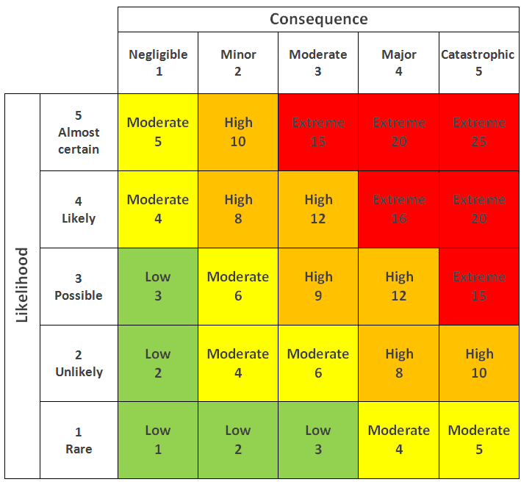

*Fig 4: RAM*

Risk Level **Before** Risk Reduction Activity is: 4,3 = **12 (High)**

Risk Level **After** Risk Reduction Activity is: 3,2 = **4 (Moderate)**

* 1. **Implementation of Internal Controls and Compliance**

After the development stage of the system, the system cannot be put in place unless it meets all the IT control and compliance requirements. This is also considered as a prerequisite to pass the final stage gate before deployment.

The internal controls framework usually includes: control environment, risk assessment, control activities, monitoring, information and communication. Compliance controls are a set of guidelines designed to maintain the process of an organization in accordance with the respective regulations and legislation it covers. Therefore, the system implementation requires adhering to various compliance controls while it should have passed all the internal controls mentioned above.

1. **Communications Plan and Risk Mitigation**
   1. **Project Audience**

| **Group** | **Participants** | **Interests** | **Expectations** |
| --- | --- | --- | --- |
| Core Team | Executive Sponsor, Business Manager, Project manager, SE Lead, Customer Focals, Functional managers, IT Lead | The overall project | Successful completion of the project,  Providing an excellent Customer Experience |
| SE Team | SE Personnel, Change and Configuration Expert, Life Cycle Documentation Personnel, SE Lead | The design and system life cycle along with technical details of the project including its operational support | Successful design and implementation of the system for the required purpose and provide technical maintenance and support for it. |
| IT and Data Collection | IT Lead, IT Admin, R&D Experts, Risk and Data Analysis Experts, Functional Managers, Systems Support and Training Personnel | Performance of the facilities, equipment and technical processes used in the system of the project and its operation and service. | A reliable, efficient and solid IT and communication to enable the optimal performance of the system. This also includes ensuring proper operation of the system by a trained professional to ensure good service |
| Facilities | Data center Staff, Communication Center, IT Service Center | The implementation, operation and functionality of the required items in the SAP | Enable the functionality of the developed system to reach its full potential |
| Customers | Customers, Customer Focals, Customer Testers | Operation, functionality and performance of the project plan | A well integrated working platform for the intended purpose (Here, it's the development and training of sports personnel) |
| Others | Finance Team, HR, Field Engineering Lead, Sports Management and Supervisors | Their interest includes everything apart from the above like the Business impact, Practical field impact, Adapting staffs and training professional to the new environment etc | Successful integration, allocation and monitoring of the system with their respective working departments to provide better results. |

* 1. **Information Needs**

The regular meetings at place to discuss the elements of the project will take place weekly, communicating the progress and needs of various teams to the necessary groups or individuals.This will also include daily meetings during important phases like deliverable testing and deployment to maintain the teams focus on their responsibilities till the successful completion of that stage.

During the course of the project vertical specific or department specific meetings will be conducted by the core team and leads in presence of the project manager and functional manager to discuss matters of interest or issues related to that particular department.

The mode of the meeting could be virtual incase of a physically dispersed team or it could be a physical meeting if possible. It is the project manager’s duty to make sure the key discussions, key takeaways and decisions made during the meeting are recorded and shared with every related personnel or team. Apart from the main meeting, information processed after discussion could be passed via official email, text message in the official group or phone call (if necessary).

| **Communication Activity** | **Frequency** | **Communicator** |
| --- | --- | --- |
| Daily Tag Meet  (During Deployment and Installation) | Daily | Project Manager |
| Core Team Meeting | Weekly | Project Manager |
| Change Board Meeting | Weekly | SE Change Personnel |
| Team Briefing | Monthly | Project Manager |
| Customer Briefing | Monthly | Project Manager |
| Sponsor Briefing | Monthly | Project Manager |
| Special Meetings | When Required | An Organizer from the Respective Team |
| Gate Reviews | As mentioned in the Project plan | Project Manager |

A Generic Communication during the Project around the Project Manager is shown Below:

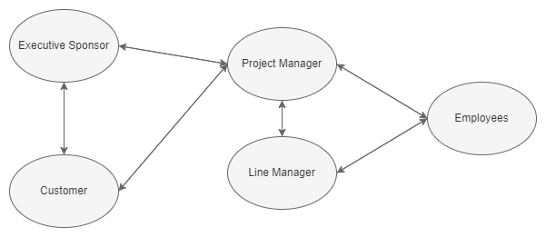

*Fig 5: Communication Channel around PM*

* 1. **Communication Calendar**

An official calendar with all the specified meetings, dates and key events will be published to every team to keep track of their timeline. This will include all the daily tags(when necessary), weekly team meetings, monthly briefs for the customer, team and sponsor, special topic meetings, change review meetings, gate reviews and other meetings as required by the project. This calendar is not subject to any change unless approved by the project manager due to any changes made to the project or other issues.

| **Communication Activity** | **Frequency** | **Days** | **Time** |
| --- | --- | --- | --- |
| Daily Tag Meet  (During Deployment and Installation) | Daily | Mon Wed Fri | 9am |
| Core Team Meeting | Weekly | Fri | 1pm |
| Change Board Meeting | Weekly | Thur | 1pm |
| Team Briefing | Monthly | First Mon of the month | 10am |
| Customer Briefing | Monthly | First Wed of the month | 10am |
| Sponsor Briefing | Monthly | First Fri of the month | 10am |
| Special Meetings | When Required | Prior Notice will be given | - |
| Gate Reviews | As mentioned in the Project plan | As mentioned in the Project plan | 1pm |

* 1. **Format/Delivery**

With respect to communication activities required for the SAP mentioned above,

**Daily Tag Meetings**

This is more of an agile method which requires the team to gather and discuss : Tasks finished, Tasks to be done, Current Tasks, Issues, Help Needed and comments. This method makes sure that the task required is completed with greater focus on it without any deviation.

These are usually timeboxed to an average of 10-15 minutes.

A daily template of this may look like this:

| **Team** | **Tasks Completed** | **Current Task** | **Issues**  **(If Any)** | **Help Needed**  **(If Any)** | **Available Personnel** | **Comments** | **Next Task** |
| --- | --- | --- | --- | --- | --- | --- | --- |
| SE | Development of the system,  Testing and Validation | Installation of Equipments to provide Infrastructure | Close Deadline | Extra Man  power | 1.  2.  3.  4. | Task Success | Verify the Installed Infrastructure |
|  |  |  |  |  |  |  |  |
|  |  |  |  |  |  |  |  |
|  |  |  |  |  |  |  |  |

**Weekly Meetings**

The Weekly Meetings will record the attendance, actions done, duration of the meeting and other key factors. The same standard format will be followed for the entire duration of the project so that all the professionals are familiar with it and know what will and will not be included in the meeting so that they can operate accordingly.

**Change Board Meetings**

All the weekly meetings will follow the same format. Only the change board meetings will have an extra description of the effect of change on the current cost, schedule and scope parameters.

**Monthly Briefs**

The monthly meetings will be recorded and presented in a powerpoint with statistical representation to understand the format easier. This representation will give an idea of what areas will be covered during the monthly briefs.

Briefing for the Team will have Technical Performance and Quality metrics

Briefing for the Sponsor will have EVMS metrics to provide information regarding the cost and schedule of the project to the sponsor.

Briefing for the Customer will include the statistical development that it could provide to the results under this program, customer operational services and generic methodology of the SAP.

**Gate Reviews**

The gate review meetings will have different requirements for its commencement but the format and method to successfully pass the review remains the same across the board. These meetings include different areas of interest as mentioned in the project plan and will follow the same timeline unless changed by the project manager.

* 1. **Approvals**

Any changes in the cost, schedule and scope metrics must be only done after an approval acceptance from the core team, change control board, project manager and the project sponsor. The effect of this change must be studied further to find the corresponding changes to be made in other relevant areas because of this change. Once this is done, the documents are to be updated with the latest metrics.

If a change does not alter the schedule, scope or cost of the project plan, an approval from the change control board will suffice. Any changes to be done quickly before the weekly meetings can be put up as a change request to the change control board. The board will then decide if it can be done or not after consulting with the necessary personnel or team.

* 1. **Escalation**

The weekly meetings conducted by the project manager and main core team will include a risk analysis worksheet. This is done to ensure regular tracking and accounting for all the risks related to the project that may affect the cost, schedule,scope or other parameters.

This worksheet is presented by the project manager in a meeting where the core team and other related teams are present to arrive at a collective decision regarding the matter at hand. After coming to a conclusion about the severity and concern level, the team will then formulate a solution to mitigate the problem or solve it which can also include trade-off analysis.

The risk visibility is provided to the various team leads, executive sponsor, project manager, functional manager and the business manager. Once the solution is agreed upon it should be immediately registered in the risk assessment tool and project platform so that the other teams are aware of the change made helping them calibrate their work around it.

* 1. **Contact Information**

Required contact information for all the core members shown in section 3.3 , designated team members, managers, leads and other professionals are given below in order to facilitate communication needs during the course of the project.

**[Note:** The names of the personnel or their personal information are not stated as there is no actual individual working on this project. However, this is the format in which the Contact Information is provided. Actual names and details can be filled incase of an actual working scenario**]**

| **Name** | **Address** | **Office** | **Cell** | **Official Email Address** |
| --- | --- | --- | --- | --- |
| Mr.Hareish Raghupathy | xxxx | xxxx | xxx-xxx-xxxx | xxxx@xxxx.com |
|  |  |  |  |  |
|  |  |  |  |  |

*____________________________________________________________________________*

*End Of Master Project Plan*